ITCS473: Project – Web-Based Restaurant Management an Ordering System

* Design:
* Main Page:
* index.php

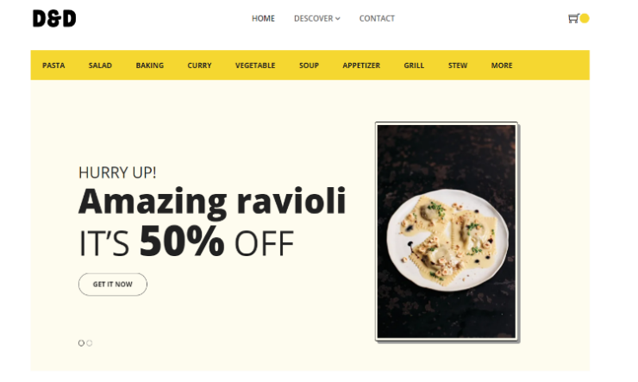

-----------------------------------------------------------------

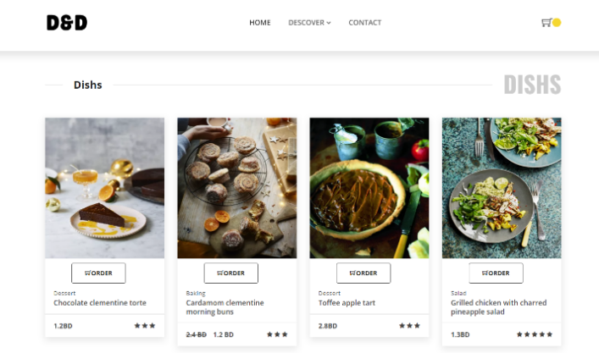

* AdminDashBoard.php

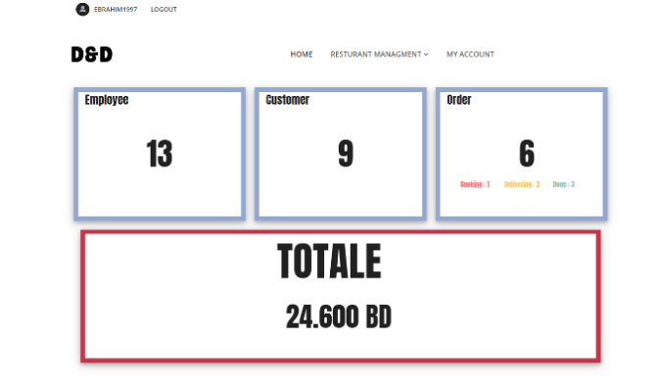

* StaffDashBoard.php

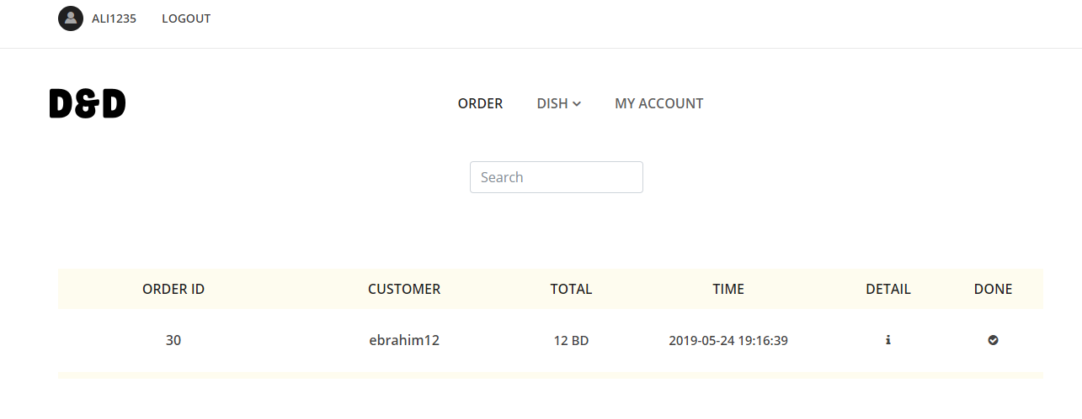

* DB and Server Scripting Chapter
* ERD

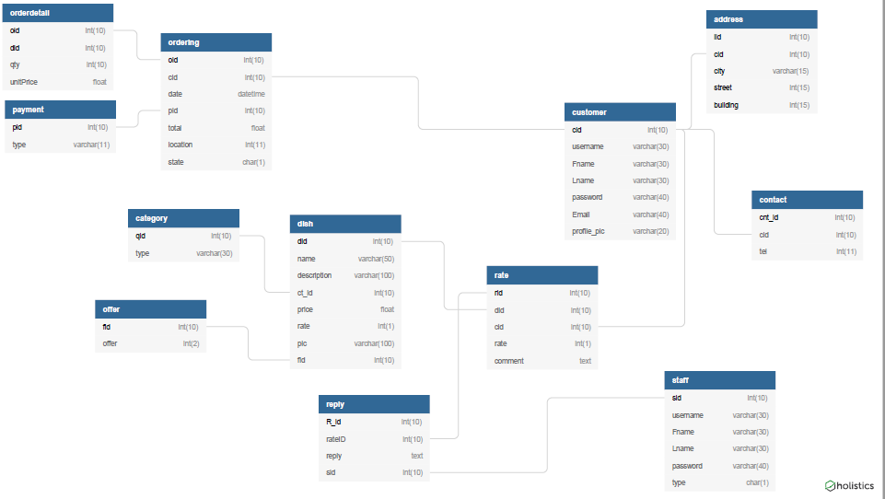

* PHP Function: -

1. display dish and user info:

retrieve dish and user data from data base and display them

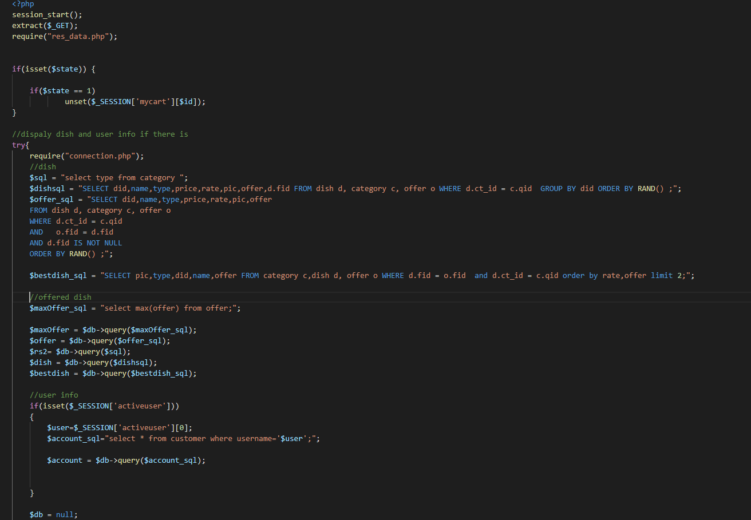

1. Update customer and staff information:

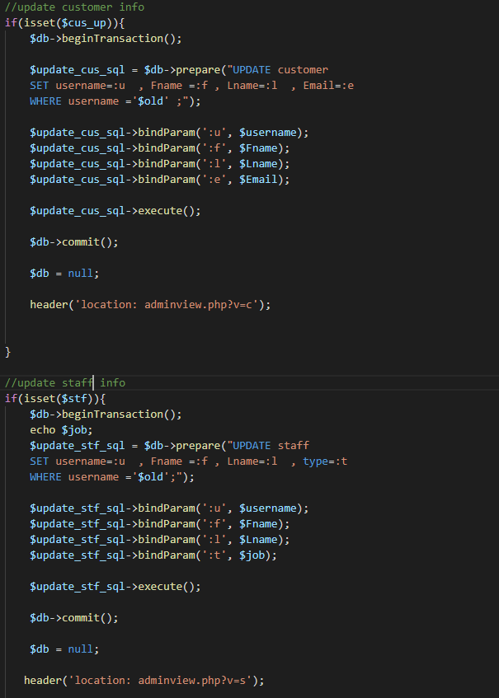

1. Add address:

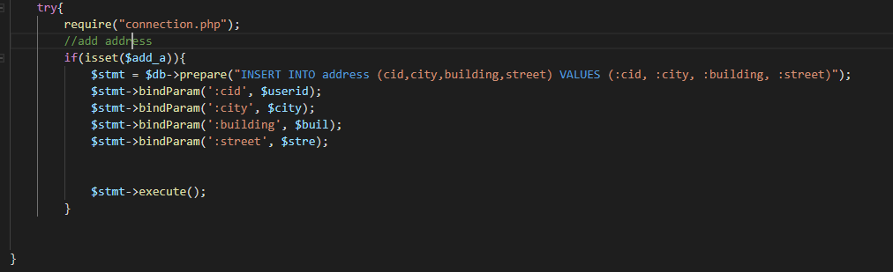

1. Add dish

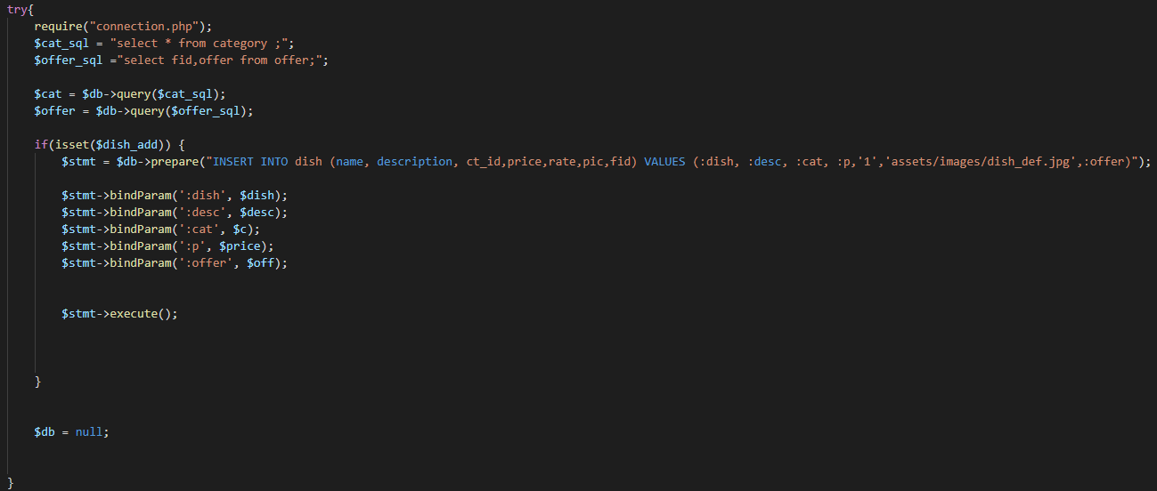

1. Add dish to cart

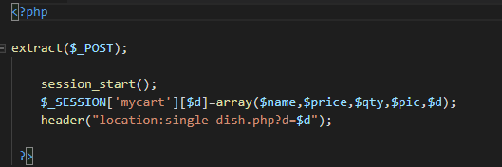

1. Delete dish, customer, offer and staff

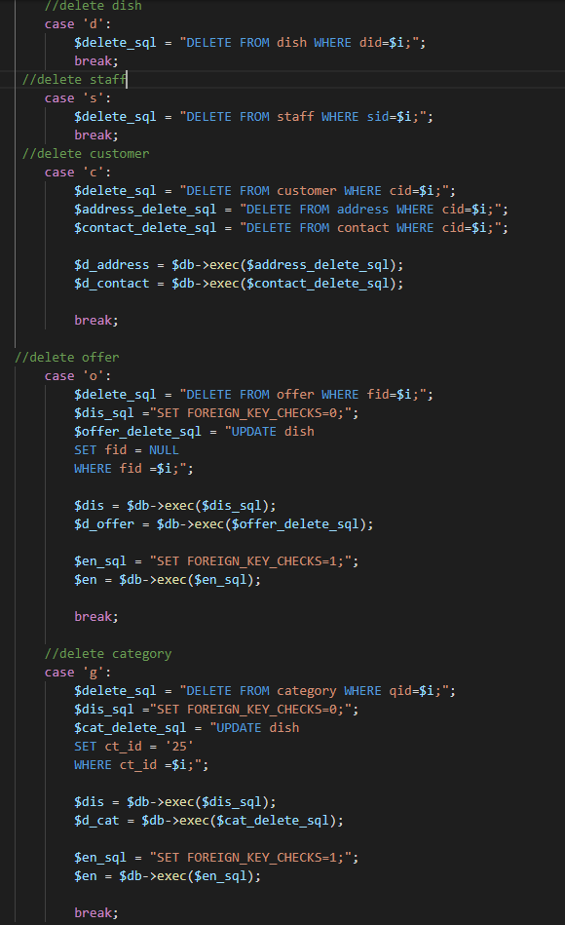

1. Place order

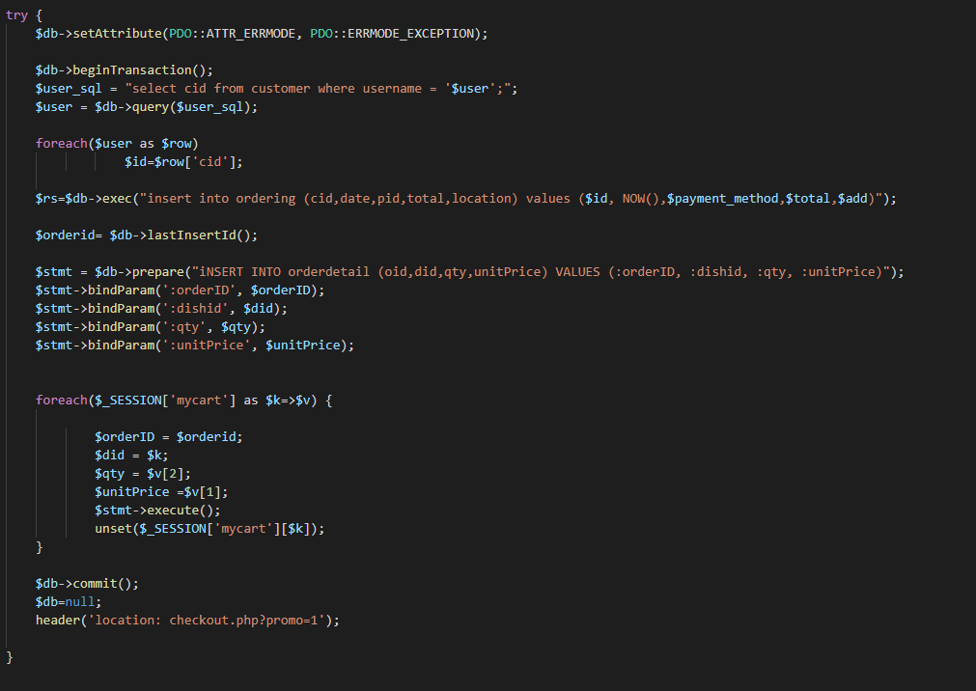

1. Login

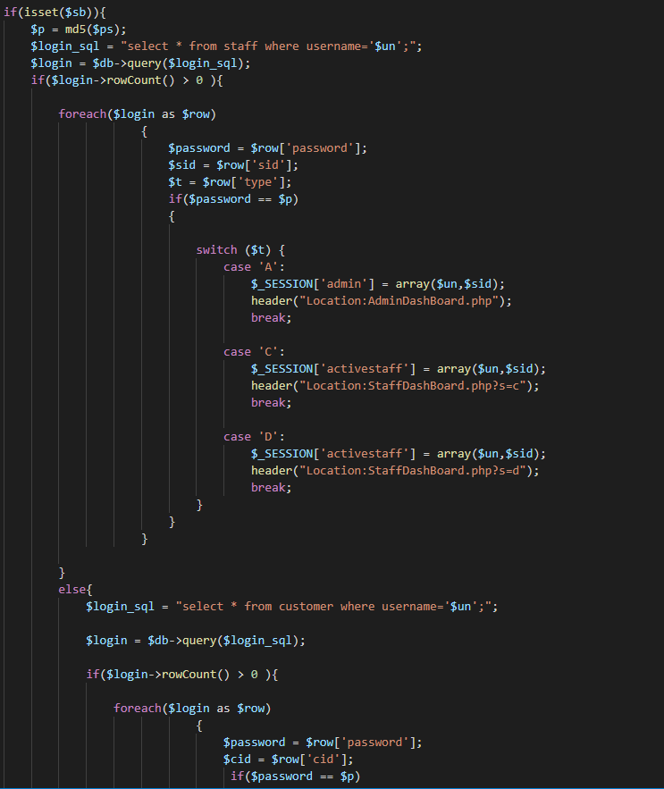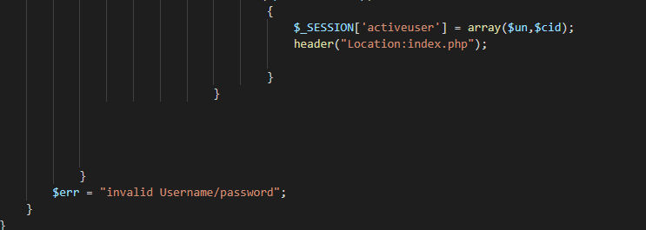

1. Customer logout

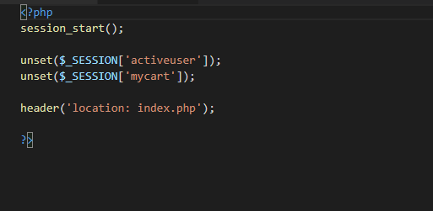

1. Rate dish

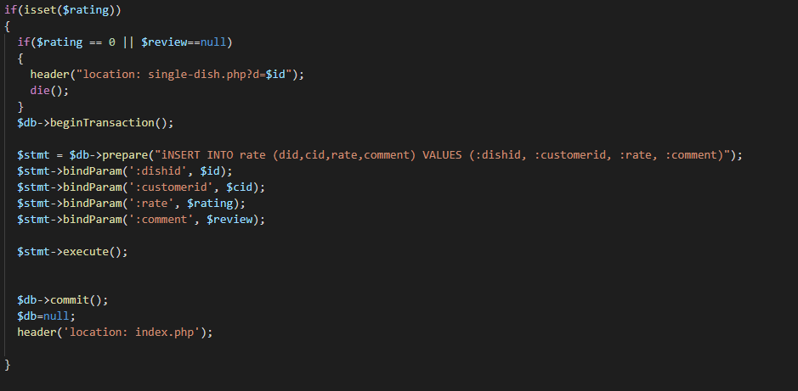

1. Add Reply

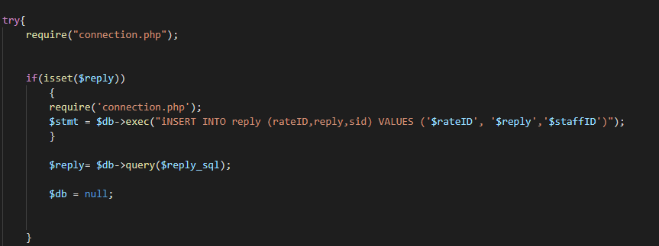

1. View customer account

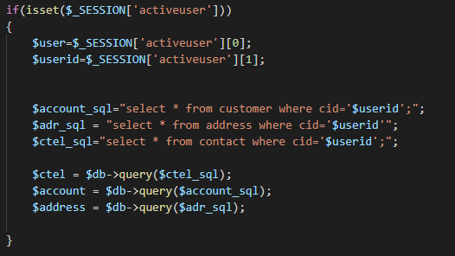

1. Customer order:

Allow customers to view their orders history.

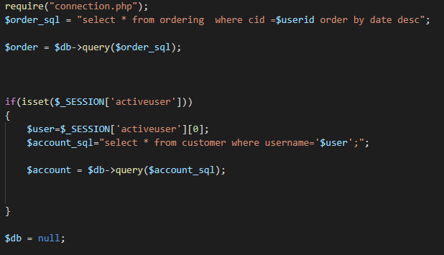

1. Re-order

Allow customer to re-order past orders

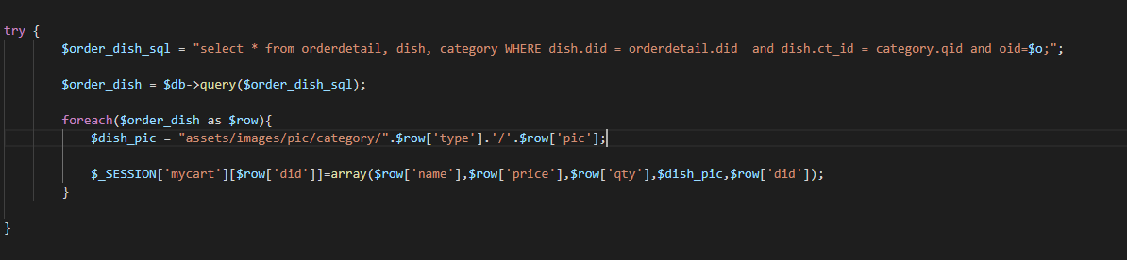

1. Validation of customer input

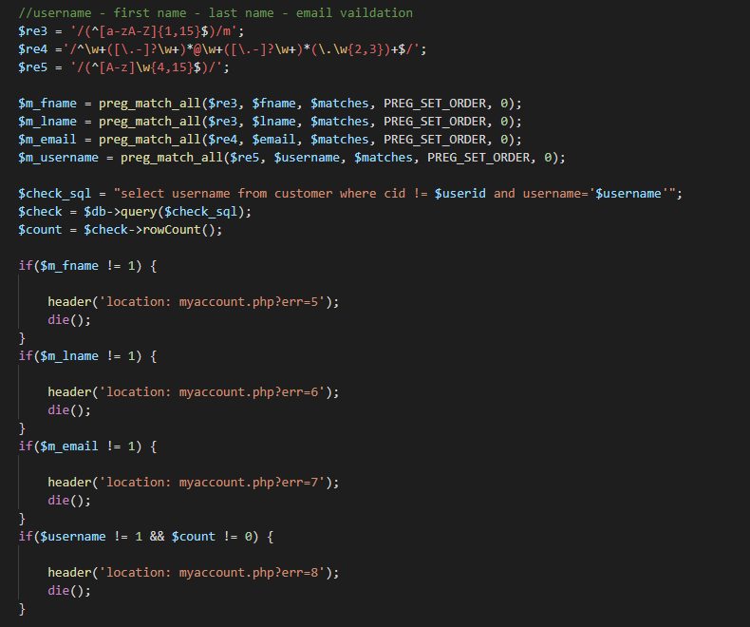

* Client / Ajax Scripting Chapter:
* Javascript function:

1. Search:

Search for dish, customer, staff using Jquery

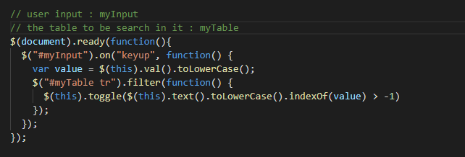

1. Pop-up form Jquery

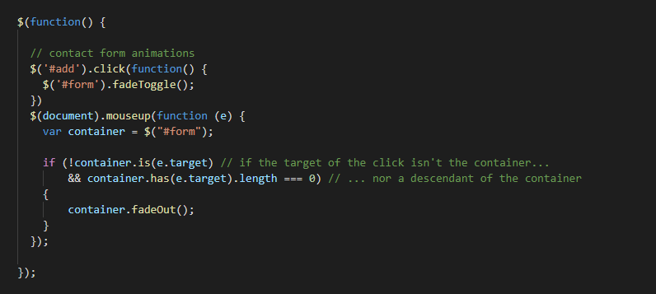

1. Customer input validation

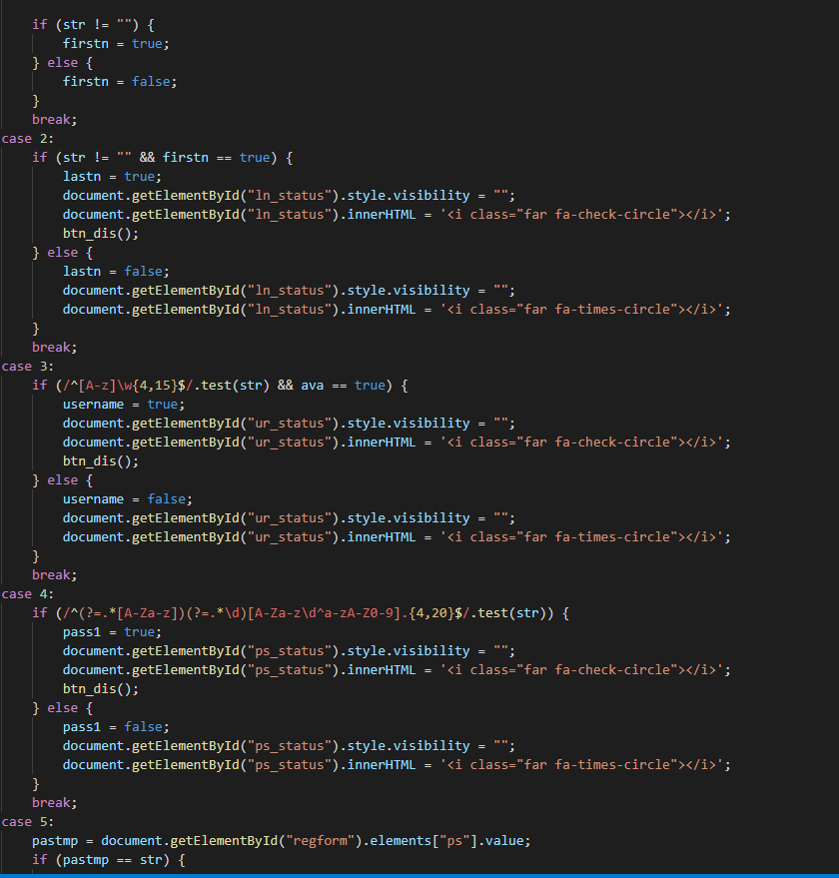

1. Send new/updated address to the update.php

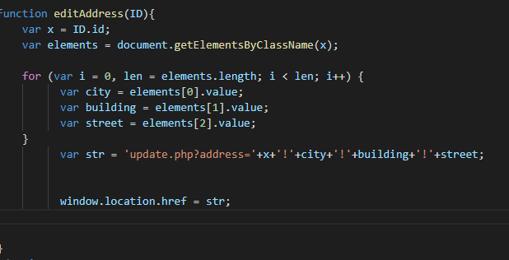

1. Call Ajax using interval time

Make the view in admin dash board information about the restaurant orders, customer and staff updated each 1 sec

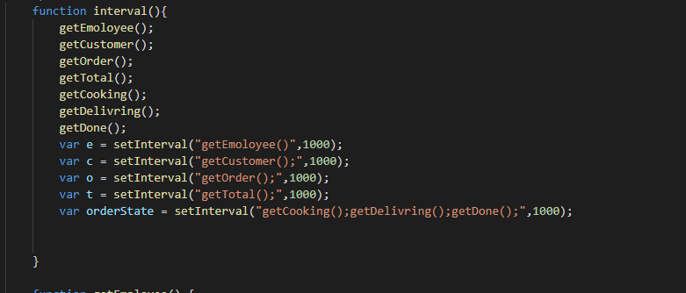

* Ajax function

1. Search hint

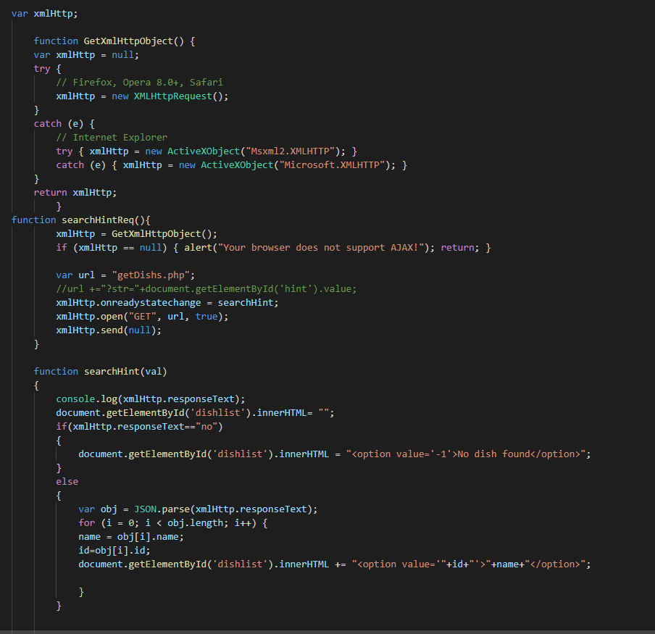

1. Get the number of staffs

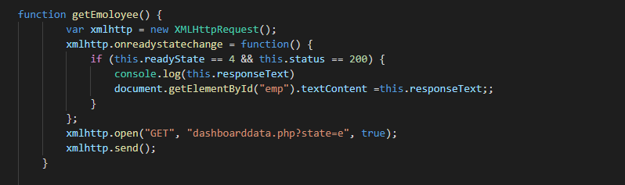

1. Get the number of customers

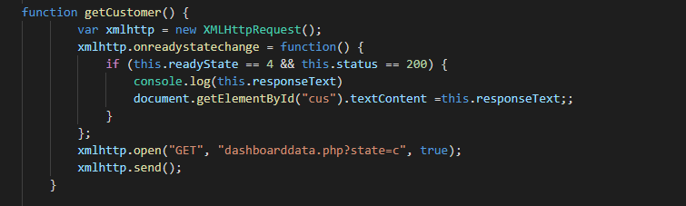

1. Get the number of Orders

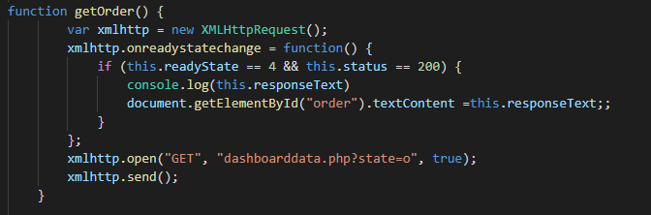

1. Get the number of started cooking Orders

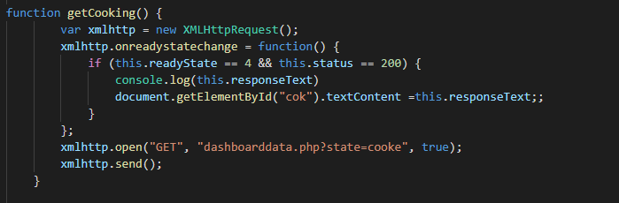

1. Get the number of started delivering Orders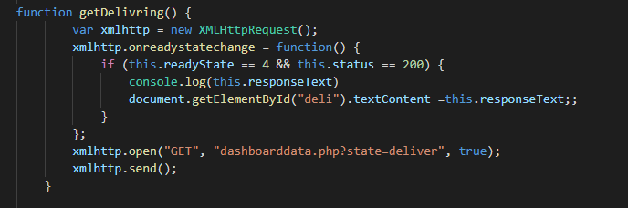
2. Get the number of started done Orders

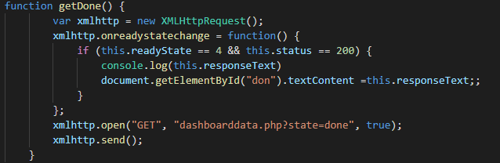

1. Get total profit of the restaurant

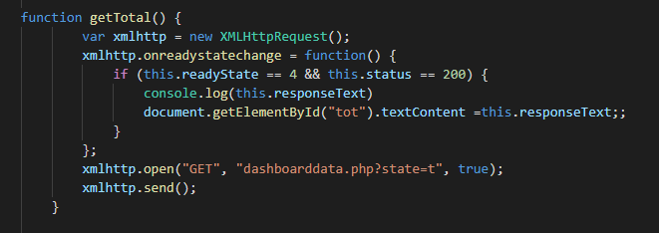

1. Dish filter and page navigation 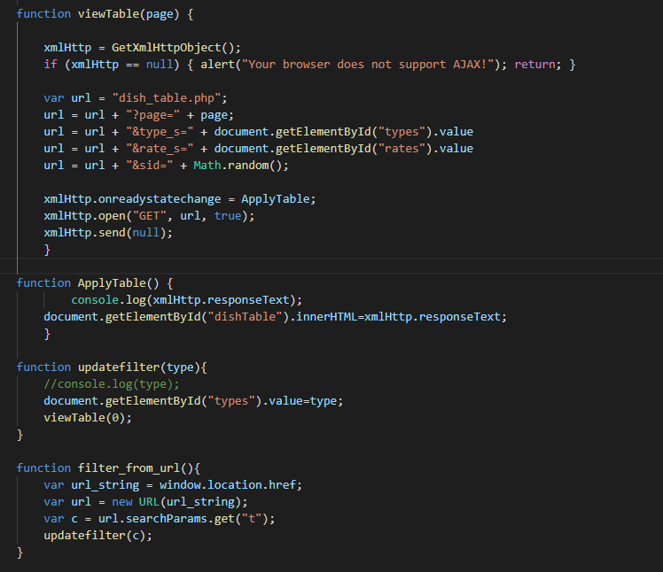
2. Check if username is token

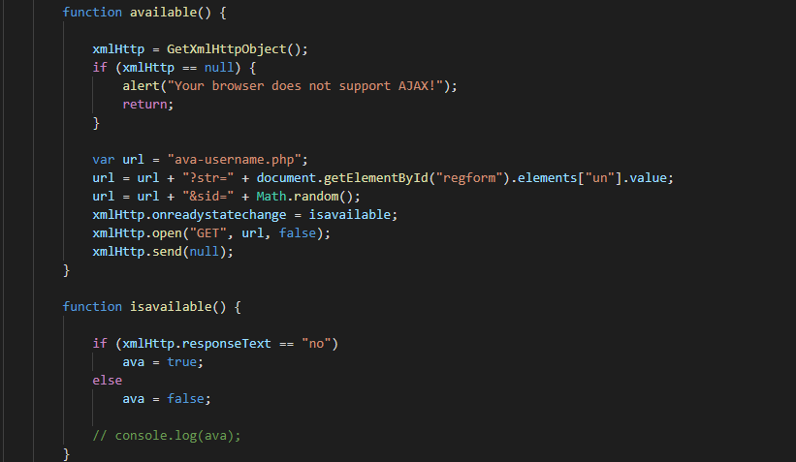

* Using the web-site instructions
* Customer:
* To create an account, you can click on register on the nav bar and enter your information.
* Once you have an account you can login.
* You can view and edit your profile on my account page
* You can view the list of dishes by clicking on dish link on the nav bar or by clicking on the name of the category.
* To add a dish in the you cart simply click on the order or the dish img then choose the quantity.
* The cart will be saved until you close the browser.
* To place your order, you must register first or login if you have registered.
* To continue you ordering process go to the chick out page and choose your address and the method of payment, then click on place order button.
* You can view your order on my order page.
* Once you order dish you can rate and add comment in the dish page by clicking on review.
* To re order a past order go to my order page and click on re-order icon in the order that you want it.
* Staff:
* Once you are login you can see the order that need to be done.
* If you order done, click on done icon.
* You can reply to customer comment on the reply page.
* Admin:
* Once you are login you can see the restaurant statistics.
* Under restaurant management on the nav bar you can view and add dish, customer, staff, offer and category, you can view review as well.
* To change customer to staff or the other way go to the customer or staff account information then click on : staff(to change from customer to staff ) , customer(to change from staff to customer)